

CS 1-B (SP26-BCS-062)
Muhammad Haider Akbar
Assignment 1
CSC103
PROGRAMMING FUNDAMENTALS

Question – 1

Part -a
The following syntax errors are present:
Cannot find symbol ( “Strings” instead of String)
public static void main(Strings[] args){
}

The word "test is missing its closing quote, which confuses the compiler about where the text ends.
System.out.print(a + "test );

The line int a = 67 needs a ; at the end to tell Java the statement is finished.
int a = 67

Errors:
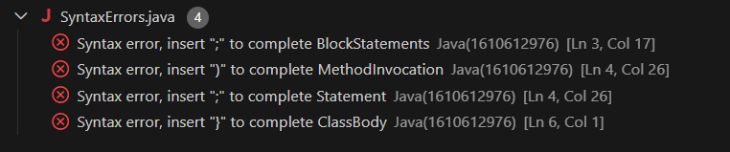

Part-b
- Using + instead of * for area calculates the sum instead of the product.
- Without parentheses, Java divides c / 3 first before adding a and b, giving an incorrect average.
- Starting i at 0 while requiring i > 0 makes the condition false immediately, so the loop never runs.

public class LogicalErrors {
public static void main(String[] args) {

int length = 5, width = 3;
int area = length + width;
System.out.println("Area: " + area);

int a = 4, b = 6, c = 8;
int average = a + b + c / 3;
System.out.println("Average: " + average);

int i = 0;
while (i > 0) {
System.out.println(i);
i++;
}
}
}

Output:
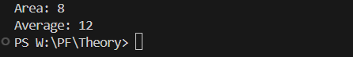

Part-c

int x = 10;
int y = 0;
int result = x / y;

Reason
Dividing an integer by zero its mathematically undefined.

Output
int a = 15;
int b = 0;
int remainder = a % b;

Reason:
Finding the remainder when dividing by zero is also undefined

Output:
int y = Integer.parseInt("abc");

Reason:
Java tries to convert the text "abc" into an integer and fails

Output:
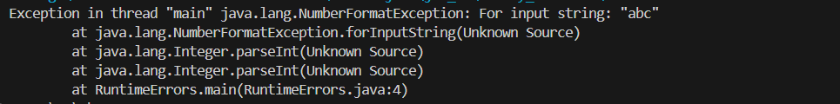

Part-d
The following table identifies syntax errors in the given program
Erroneous Statement | Error Type | Correction
count = 1; | Undeclared variable | int count = 1;
sum = count + PRIME; | Undeclared variable PRIME and sum | int PRIME = 2; (declare before use)
x := 25.67; | Invalid operator := and undeclared | double x = 25.67;
newNum = count * ONE + 2; | Undeclared variable ONE and newNum | int ONE = 1; (declare before use)
sum + count = sum; | Invalid left-hand side | sum = sum + count;
x = x + sum * COUNT; | Undeclared variable COUNT ( supposed to be count) | x = x + sum * count;
public static void main(String[] arg) | Ar should be args | public static void main(String[] args)
... + Prime) | Prime not declared ( should be PRIME) | … + PRIME)

Corrected Program:
public class Test {
public static void main(String[] args) {
int count = 1;
int PRIME = 2;
int sum = count + PRIME;
double x = 25.67;
int ONE = 1;
int newNum = count * ONE + 2;
sum = sum + count;
x = x + sum * count;
System.out.println(" count = " + count + ", sum = "
+ sum + ", PRIME = " + PRIME);
}
}

Question 2
The following table has the required elements
Element | Example from Code
Multiline Comment | /* This program will calculate... */
Single Line Comment | // first number
Special Symbol (1) | ;
Special Symbol (2) | {}
Special Symbol (3) | *
Reserved Word (1) | int
Reserved Word (2) | public
Reserved Word (3) | void
Predefined Identifier (1) | System
Predefined Identifier (2) | println
Predefined Identifier (3) | String
User-defined Identifier (1) | Product
User-defined Identifier (2) | num1
User-defined Identifier (3) | result
Standard Input Stream | N/A (not used)
Standard Output Stream | System.out

Question 3

Part-a

Task | Java Statement
Declare int variables x and y | int x, y;
Initialize int x to 10 and char ch to 'B' | int x = 10;  char ch = 'B';
Update int x by adding 5 | x += 5;
Declare and initialize double payRate to 12.50 | double payRate = 12.50;
Copy firstNum into tempNum | int firstNum = 1;  int tempNum = firstNum;
Swap x and y | int x = 5;  int y = 10;  int temp;  temp = x;  x = y; // x is now 10  y = temp; // y is now 5
Output x, y, and x+12/y-18 (x,y are double) | System.out.println(x + " " + y + " " + (x + 12/y - 18));
Declare char grade and set to 'A' | char grade = 'A';
Declare int variables to store four integers | int a, b, c, d;
Copy double z to nearest int x | int x = (int) (z + 0.5);

Part-b
Initial values: a = 5, b = 6, d = 2, c = undefined
Statement | a | b | c | d
a = (b++) + 3 * ++d; | 15 | 7 | UND | 3
c = 2 * d + (++b) + a; | 15 | 8 | 29 | 3
b = 2 * (++c) - (a++); | 16 | 45 | 30 | 3
d = d++ + d + b++ + b; | 16 | 46 | 30 | 98

Part-c
Statement | a | b | c | sum
sum = a + b + ( int) c; | 3 | 5 | 14.1 | 22
c /= a; | 3 | 5 | 4.7 | 22
b += (int) c - a; | 3 | 6 | 4.7 | 22
a *= 2 * b + (int) c; | 48 | 6 | 4.7 | 22

Question 4

import java.util.Scanner;

public class CarpoolCalculator {

public static void main(String[] args) {
Scanner input = new Scanner(System.in);

System.out.print("Enter total miles driven per day: ");
double totalMiles = input.nextDouble();

System.out.print("Enter cost per gallon of gasoline: ");
double costPerGallon = input.nextDouble();

System.out.print("Enter average miles per gallon: ");
double milesPerGallon = input.nextDouble();

System.out.print("Enter parking fees per day: ");
double parkingFees = input.nextDouble();

System.out.print("Enter tolls per day: ");
double tollsPerDay = input.nextDouble();

double dailyGasCost = (totalMiles / milesPerGallon) * costPerGallon;
double totalDailyCost = dailyGasCost + parkingFees + tollsPerDay;

System.out.println("YOUR DAILY DRIVING COST: " + totalDailyCost);

System.out.println("Breakdown:");
System.out.println("- Gasoline: " + dailyGasCost);
System.out.println("- Parking: " + parkingFees);
System.out.println("- Tolls: " + tollsPerDay);
}
}

Output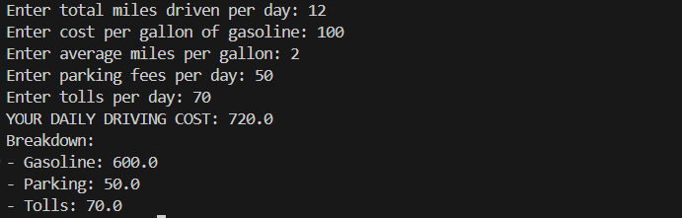

Question 5

import java.util.Scanner;

public class ReverseNumber {
public static void main(String[] args) {
Scanner input = new Scanner(System.in);

System.out.print("Enter a five-digit number: ");
int number = input.nextInt();

int a = number % 10;
int b = (number / 10) % 10;
int c = (number / 100) % 10;
int d = (number / 1000) % 10;
int e = (number / 10000) % 10;

int reversedNumber = (a * 10000) + (b * 1000) + (c * 100) + (d * 10) + e;

System.out.println("The reverse order number: " + a + " " + b + " " + c + " " + d + " " + e);

}

}

Output


